Aurora Market Research

Article for Marketing Week
10/04/06

Developing involving online surveys

The growth of online market research

From a practically a standing start no more than 5 years ago, online market research now accounts for around 10% of the UK research market, and most commentators predict that this proportion will only continue to increase over the coming years.

Clients have been experiencing the many benefits of online surveys, for example the cost savings, the speed and accessibility of results, and the quality of data. In addition we also have the knowledge that a far higher proportion, up to a third, of market research in the US is conducted online and this proportion will continue to rise.

So it must be great times to be in online market research?

Well, you would think so. It has never been easier to conduct a market research. It is possible to survey anyone you have an (opt-in) email address for, or anyone who visits your website. Or alternatively you can ask one of the growing numbers of internet panel providers to run a survey for you using their willing panellists.

However the prevalence of both easily available survey software and internet panel companies is now delivering the ability to conduct market research capability to more and more people, and importantly not just market researchers.

This means that everybody and anybody can now run surveys. Indeed the traditional role of a market research executive in an online agency environment is potentially being somewhat squeezed, as end clients are deciding to forego the traditional route of commissioning a research agency and taking this Do-It-Yourself approach.

However the concern of market researchers with all this prevalence is maintaining the quality of surveys. With more and more non-researchers running surveys, these are serious concerns within the industry. Are the right questions being asked correctly of the right people? Are respondents still being considered fully?

In all markets, reducing the quality of products always leads to lower sales, which in market research survey terms means lower response rates and greater concerns about the validity of the data collected.

So yes, it is a great time to be in online market research, but as market researchers we need to ensure that online surveys retain the quality that engenders respondent involvement and, also as importantly, develop online surveys to keep up with the technology that is available.

The role of small independent online researchers

As already stated, most online survey software is designed for anybody to run surveys from questionnaire development to reporting. However we believe that putting online survey software directly into the hands of experienced market researchers provides an excellent proposition.

The development of online survey software has enabled the establishment of small independent online market agencies, with vertical organisational structures, with the vast majority of staff in these agencies are researchers actually using the survey software themselves.

This not only enables streamlined, cost effective structures, but also provides clients with the opportunity to deal with experienced all-round market researchers being closer to all aspects of the survey process from questionnaire design to analysis of results. This is in stark contrast to the more horizontal structures of larger agencies, where researchers remain somewhat more distanced from data collection itself; structures which of course were established to conduct research by more traditional methodologies (i.e. face to face/ telephone/mail), which have both the requirement and associated costs of large Field and Operations departments to conduct the research.

All this news is great for small independents. We have always been able to compete realistically with the larger agencies in the qualitative research arena, offering both the well known experience and cost savings benefits. However the continued recent development of online research software now enables small independents to also compete realistically on the quantitative front too; and for the first time, offer a full service approach without the requirement to subcontract fieldwork.

The rising expectations of internet users

As online researchers we also need to take a step back and look at what is happening to the medium as a whole. We all know the internet has become extremely important in people’s lives. Here in the UK, 47% of adults use the Internet on a daily basis, equating to a massive 27 million people using the Internet at home or at work.

On average, internet users spend a quarter of their weekly media time on the internet, making it the second most commonly used medium after television (1). And, with three quarters of home users have a broadband connection (1), website developers and online marketers are making more and more use of advanced interactive software solutions to make their creative offerings more interactive and involving.

This means that internet users are now becoming accustomed to ever more technologically advanced websites and online marketing activity which offer more interactive experiences and general expectations of what can be done on the web are being raised significantly.

In short, the days of a nicely designed text based website, in Times New Roman font size 12 with the odd image here and there, are numbered.

But aren’t Online Surveys just Times New Roman font size 12 with the odd image here and there?

Well, yes some companies are still offering that, but we believe that things need to move on.

In the online research market, surveys are our products and respondents are our customers. When we create online surveys we need to “sell” them to respondents, and then sell them again.

Survey incentives in the form of cash, or entry into a prize draw can help with this. However, as we all know, promotions can help persuade people to try, but unless the product is of enduring high quality you are not going to keep customers interested. This means that respondents will drop out of surveys and response rates suffer.

We firmly believe that respondents take part in online surveys because they are fun and involving. Yes, incentives help to get people to enter a survey, but our experience has shown that a high quality survey design with interactive elements generates higher involvement and better survey results.

Examples of interactive elements

By simply incorporating some of the software solutions being used on websites, such as Macromedia Flash into survey software solutions such as Confirmit, we can create involving and enjoyable survey applications to keep respondents interested.

Below are just a couple of examples of how we are doing this. Beneath each example are actual quotes from respondents taking a survey incorporating a tool of this type.

Justin Alderson is Director of Aurora Market Research (www.auroramr.com)

References:
1 - [BMRB Internet Monitor, January 2006]

Continuous rating of media files (e.g. TV Advert)

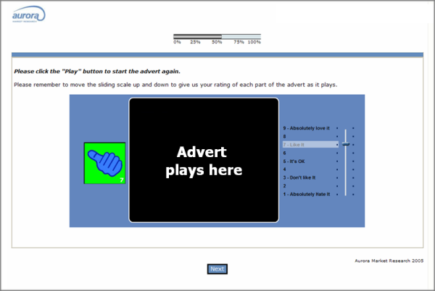

“I liked the interactive elements which give feedback on my answers; this made me feel as though my contribution was valued.”
“Fun, enjoyed doing the survey”
“It was a good one; it kept me interested, something a bit different and interactive”
“Really enjoyed this questionnaire, it gives you some enjoyment while filling it in”

Card Sort

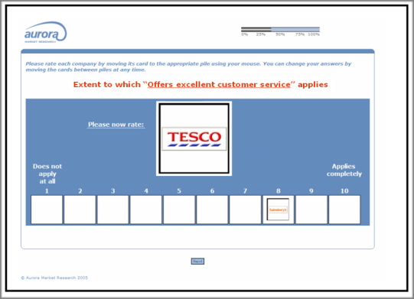

“I enjoyed this questionnaire. It was interactive and there weren't too many large grids to fill in.”
“It was clear, simple and easy to understand. I liked the 'deal out the cards' technique.”
“I though that the usage of the card system to rank different companies was inventive and different,”

